Abstract:
This project was to design a building that would be beneficial to the college campus in physical and mental ways. It also had to be designed to meet LEED v4 standards which will qualify it as a green building. Physical and mental aspects had to be incorporated into a design that would encourage the campus community to be active, while also catering to the mental needs that all college students will face over the course of their years at college. The green building aspect of this design was done by incorporating green building practices like a green roof, solar shingles, a rain water filtration system, geothermal heating and cooling and the use of passive solar techniques to heat and cool rooms. We were able to achieve this goal by designing the college a new wellness center that incorporated all of the college’s needs. This facility is located inside the perimeter of the campus, meets most, if not all of the wish list needs and wants, and was done to LEED v4 standards. Our design proposes a wellness facility for Elizabethtown College that encompasses mind, body, and spirit.
Intro/Problem Statement:
After hearing from Dr. Wunderlich and Dean Calenda, we were able to formulate a problem statement for this project. Elizabethtown College is looking to expand their wellness facilities; our project was to propose a design for a new wellness facility that embodied mind, body, and spirit. Using our mechanical engineering and sustainable designing skills we had to design this building keeping in mind the “wish list” that was given to us by Dean Calenda, the college, and the professor for the course. Keeping these wishes in mind, we had to design a building that would seamlessly be integrated into the current college campus, create a design with the ability to make students want to come and use the facility, make sure the building was student-centered and comfortable, and have the building be learner focused. We also had to incorporate sustainable features so that the building would have low building cost and be energy efficient. The building also needs to have links to community resources including outdoor fitness such as bike trails and green spaces. The building also has to be linked to learning communities. Along with all of these design specifications we also had to ensure the building had a 200m indoor track, six to eight new locker rooms, a new sport medicine facility, equipment and apparel space, a laundry room, a new weight room, a multipurpose room, at least one class room, a social space, and at least one lobby/ lounge.
Site Location:
Choosing a site location was the first decision we needed to make for this project. There were three different potential sites we analyzed for placing the building: behind Thompson Gymnasium, between the soccer stadium and the turf field, or behind the soccer field where the softball field is currently located.
The first site was behind Thompson Gymnasium. This site involved adding on to and renovating Thompson Gymnasium. When we first looked at this location, we thought this site would be a good way to solve this problem, not only would we gain much needed space in this area of the school, we would also be able to renovate the older parts of the gym that need the remodeling. However, looking at this area around the gymnasium we realized that the sloping hills next to the gym not only would be very difficult to work with, but also does not provide us with enough space to incorporate many of the features listed on the wish list.
The next location we looked at was the field space between the new lacrosse seats and the soccer stadium seats. This location we determined would be very nice and easy to build on. The location was very flat and had a large enough area to build an indoor track within the space. However, if the building was placed in this area we felt it would become an eye sore. The building would look as if it was squeezed in between two already placed structures, the shadows and glare from the building would play a factor for soccer, lacrosse, and field hockey games. With the building being centrally located inside of the campus, we would not be able to add any additional parking near the building for either outside events or community members using this space, if this space ends up being used by people outside of the campus.
The final location we looked at was the space that was first brought up to us by Dean Calenda, which is located behind the soccer field toward the south west. This area is on a slight slope but could be leveled to create a flat surface that could be easily built on. Once this would be done you would be left with a very large area that can easily fit what has been asked that we build in this project. This location is not quite as centralized as the other options. However, it is located between two large housing facilities (Quads and Hackman Apartments) that hold a large number of students. It also allows us to put in a big parking lot right next to the building, which will definitely be needed. This location also provides us with the largest area of the three locations.
Taking all of these sites into consideration we placed them in a Pugh table (See Appendix D) and determined that either the area between the soccer and lacrosse fields or behind the soccer field would be the best locations for this new building. When it came to choosing the final design we determined that, although you would have to tear down the softball field in the process, the space behind the soccer field would be the best location. This has to do with the shear aesthetics of the location compared to the other and the fact that the space fit all the needs with space to spare, if the design would need to be modified. It would also provide closer athletic facilities to the soccer, baseball, and softball teams. (See Appendix C and D)
Proposed Design
If we use the space given to us we will be able to create a building that has a floor plan that takes up an area 500 feet long by 250 feet wide. Once we built the building on the space, that was just discussed, we will be able to generate a front lobby space that is a total of 3,000 square feet, a field house area that has a total area of 86,400 square feet, a new weight room that is 2,400 square feet, six new locker rooms consisting of a total of 8,400 square feet, a new sports medicine facility that is 2,800 square feet, a multipurpose/storage room of 2,800, a class room that is 900 square feet, and 4,500 square feet allotted to student wellness.
The lobby space in the front of the building can be used for check-ins with a main desk. With the space still available we will be able to add seating along with the possibility of some type of juice bar similar to the blue bean area in the BSC. The field house area will be able to hold a full indoor track. This will be able to be used to for NCAA indoor events. In this field house we will also be able to have one or two batting cages off to the side along with three courts in the middle of the track that would be covered by multi-purpose flooring allowing for multiple sports to be played on the surface. This will provide all our outdoor sports teams with a place to practice when the weather is not ideal outside.
There will be six locker rooms built into the facility that are capable of holding teams of up to 35 players. The new locker rooms will allow all sports teams to have a locker room for their seasons and will allow all visiting teams to have locker rooms when they are at the college. All locker rooms will have their own bathrooms. These bathrooms will not only have just sinks and toilets, but also showers as well. The new sports medicine facility will be much larger than the old room. Due to this will be able to have two offices, a laundry room, and a tub room inside the space and still have room for sport rehabilitation and sports medicine to take place.
There will also be a multipurpose/storage room that will be large enough to house most of the equipment that is stuffed into the Thompson gym at the moment and will still have a large enough space for a janitorial service station. A roll door between this room and the field house will allow for equipment to be easily moved from storage into use. The class room space will be able to have a dual use with the help of removable desks and chairs making the space become available for E-fit classes. The final room in the building will be used primarily for a spiritual room. This room will be very calm and not catered to any specific ethnicity or religion but just a quiet calm room to relax.
LEED v4 Self-assessment:
The entire building then had to be built using sustainable design practices. Because this was hard to determine just by adding sustainable aspects we used the LEED v4 assessment sheet to determine if our building was actually sustainable. The assessment sheet is broken into 8 parts that focus on different aspects of the building process and function. We accumulated 43 points in our self-evaluation, which made it LEED certified (See Appendix E). We were able to gain credits in the following ways:
Location and Transportation
For this aspect we were able to gain LEED credits for adding bike racks. This is a reasonable object to be put into the building plan because, even with the size of the campus, giving the students and faculty an incentive to ride a bike to the location will help with making it more accessible. It will also encourage more people to make their way to the building.
Sustainable sites section
For this section we were able to gain credits by using a green roof that in turn will help with rainwater management. And because the building is being placed within the campus boundaries we will not have to worry about the building’s light pollution wondering into unwanted locations such as residential areas.
Water efficiency
We were able to gain credits for this section by working with reducing indoor water use. This was done with the help of our green roof and the filtrations system created by the roof. The green roof collects water that can be used to flush toilets in the building.
Energy and atmosphere
We were able to gain credits for this section by optimizing the energy performance of the building with the help of solar shingles, the green roof, passive solar technique, and the use of geothermal energy. These four energy saving practices also go along with renewable energy production which also gained us credits.
Materials and resources
For this section we were able to gain credits by recycling construction and demolition waste materials during the construction of the building and the demolition of the site. We would also like to propose the idea of looking into finding materials from other demolitions done in the area.
Indoor environmental quality
For this section we were able to gain credits by eliminating the use of VOC (Volatile Organic Compounds) materials during the building process. During the day most of the building will be lit using passive solar techniques. The building has lots of windows to allow for natural lighting. We were able to gain a few more credits by placing sound buffering panels in the field house area to improve acoustics.
Along with what was mentioned above there are many other required aspects of the LEED v4 assessment sheet. All of these requirements have been looked at and accounted for in during our design.
Sustainable Features:
Sustainability was a key aspect we tried to design the wellness center around. One of the main green features of this building is our green roof. Only the main roof over the field house will have the green roof. A green roof is a partially or completely covered area on the roof of a building that is covered with plants. The green roof itself has vegetation on the top portion, a waterproof membrane on the bottom, with a medium in the middle. A green roof over a large area such as ours can become very heavy. In order to reduce weight we chose to use the shallowest medium possible, which is ranges from 2-12.7cm. This is cut the weight on the roof considerably and will need much less maintenance to keep alive. There is also a slight pitch in the roof to help water drain down to edges of our system where it can be recycled.
This roof will serve several purposes for the new building including providing insulation, creating wildlife habitat, absorbing and filtrating rainwater, along with increasing the life of the roof. The main purpose of this roof will be to filter rainwater for use in the building and curb the amount of rain runoff from the roof. However this rain water will more than likely not be able to be used as drinkable water and come out as grey water, because of this we have to figure out another use for it. It was suggested to us to use this grey water for a seemingly non-existent use, that being the water for the toilets, most toilets actually use fresh drinking water to flush excrement down the drain. Seeing as how this could be a big waste of water, we changed to using grey water. This will reduce this building’s water use by a considerable amount.
When looking at the surface area of this building we realized that we had a very large amount of roof space, aside from the main roof, that could be utilized on each of the wings of the building. Seeing that each wing has a surface area of approximately 16,800 square feet we determined that we could have a pretty considerable Photovoltaic (PV) array on these roofs. A Photovoltaic system is a powering system that when designed will be able to capture and use the solar power of the sun to produce energy with the use of photovoltaics. Once a PV system would be put on the roof it will be able to make a dent in the energy needed to run the building.
This type of system could be done by one of two systems that we have learned of, the solar panel or the solar shingle. When first looked at we felt that solar panels would be the best choice; however, after considering our research we were able to determine that solar shingles would be the better choice. Although the price of solar shingles may be higher, the energy production was almost identical. Solar panels are known to maintain a conversion efficiency rate of about 20% and the solar shingles have now reached a conversion efficiency rate of 19.9%. With power production being what is really being looked at along with the aesthetics the solar shingles win out. The shingles come in a darker color and sometimes even with a blue hue to them, which with a school that has blue as their school colors makes for the perfect fit for the building.
When looking at the energy usage of a building we have to look at the heating and cooling of a building, especially when dealing with a building of this size. To offset this massive amount of energy needed to cool this building we looked into the use of geothermal heating and cooling. The way that geothermal heating and cooling works is multiple holes are drilled in to the ground and then are piped off. A water and antifreeze mixture is circulated through the pipes. As it circulates through the pipes it absorbs the earths heat and brings it up to the geothermal heat pump. This works because the ground is always held at a certain temperature of around 55 degrees Fahrenheit, so when air is fed through the geothermal system, instead of turning a 30 degree room to a 70 degree room (an increase of 40 degrees) you would only need to change the air temp of the geothermal from 55 degrees to 70 degrees (a change of 15 degrees). This method allows for a great reduction in energy usage. These systems also typically pay themselves off in about 5-10 years, depending on the location and government incentives.
We also looked at some more passive ways to create heat for the building. To do this we have decided to try and use passive solar heating technique, the first being the use of a thermal mass. A thermal mass is a property of the mass of a building that enables it to store heat. We have been able to do this with the concrete floor of the building. Using sunlight through the windows will allow the floor to soak up heat and then radiate that heat throughout the day and night to keep the room from cooling to an uncomfortable temperature.
In order to make this solar mass effective we needed to have a way to get heat to our thermal mass. Using many windows throughout the building will again help with the heating of the room throughout the day, but is also used to cut down the amount of lighting need for the building during the day. This idea was incorporated throughout the entire building to limit the amount of man-made light needed while also adding to the aesthetics of the building. Natural light is also much easier on eyes, making the people in the building more comfortable and making this wellness center a place for people to feel relaxed and comfortable is one of our main goals. (See Appendix A and B)

Conclusion:
Our design provides Elizabethtown College with a new wellness facility that will fulfill mind, body, and spiritual needs. The wellness center meets all the requirements given to us by the college and is designed to be LEED v4 certified. The building will stand where the current softball field is and will be able to be used by the student population, as well as staff, but still has space capable of be used by outside personal if the situation presents itself. It also has green features on the building that will not only help with the aesthetics of the building but will help with keeping the costs of the building down while it is in use. While working on this project we learned a multitude of different things about the process of designing a green building. Some of the most notable things we learned are just how difficult and time consuming the process is. We were given free rein on how to design the building, as long as we were able to meets the requirements given. And because of this there were long hours put into how the final design would look and function. This being said we feel that this is a completely viable design that could be used as a basis when the college begins the official design.

References
http://www.greenroofs.com/
http://www.geoengineers.com/blog/green-roofs-and-stormwater-filtration
http://greenupgrader.com/2347/flush-your-toilet-with-recycled-gray-water/
http://renewableenergysolar.net/solar-shingles-vs-solar-panels-whats-the-difference/
Notes from Sustainable Engineering EGR276
Notes from Green Arch. EGR343
Checklist and PowerPoint from public folder of Dean Calenda
http://digtheheat.com/geothermal_heatpumps/geothermal_cooling.html
http://greenpassivesolar.com/passive-solar/building-characteristics/thermal-mass/
http://ahroofing.com/green-roofs/
http://www.celsias.com/article/five-awesome-solar-trends-how-they-will-change-wor/
http://cleantechnica.com/2012/11/25/geothermal-heat-pumps-how-they-work-how-to-get-one/

Appendix A:
Blue Metal Roofing-
http://www.camelsteel.com/product/1613915270-213217253/Blue_Corrugated_Roofing_Sheet_Zinc_Aluminum_Roofing_Sheet_Metal_Roof.html
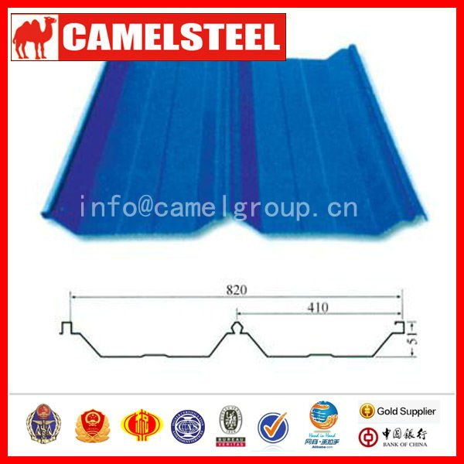

Green roof-
http://www.lid-stormwater.net/greenroofs_cost.htm
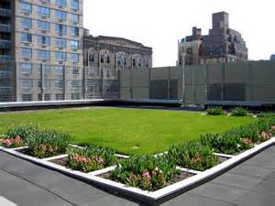

Solar roof-
http://www.dowpowerhouse.com/index.htm
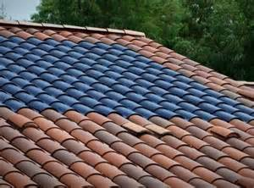

School roof-
www.etown.edu
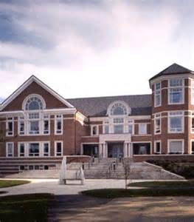

Appendix B:

 | Green Roof | Blue Sheet Metal | Solar Roof | Shingles
Aesthetics | + | + | + | D
Sustainability | + | - | + | A
Cost of Material | + | + | - | T
Cost of Installment | - | + | - | U
Life-span | + | + | + | M
 | 4 | 4 | 3

Appendix C:
Site locations on campus-
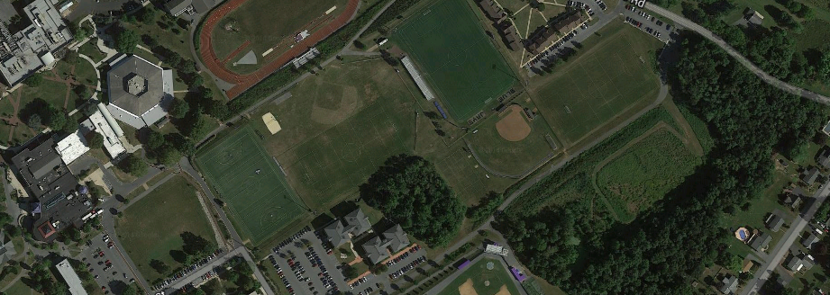
3
2
1

Final site location-
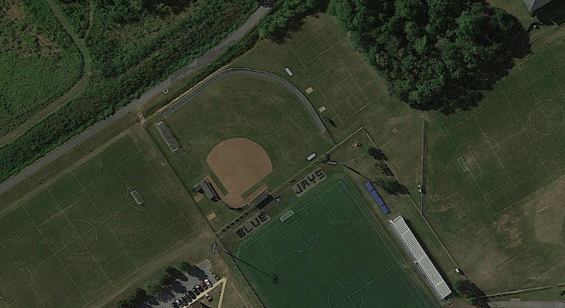

Appendix D:

 | Thompson Gym | Between Soccer and Lacrosse Fields | Behind Soccer Field | Off Campus Location
Workable land | - | + | + | D
New Renovations | - | + | - | A
Space needed | - | + | + | T
Accessibility | + | + | + | U
Aesthetics | - | - | + | M
 | 1 | 4 | 4

Appendix E
